 ,,

**Customer Requirements Specifications (CRS)**

***Commercial Module***

# **Document Information**

|  |  |
| --- | --- |
| Document Name | Commercial Management for Samuda Chemicals Ltd. (CRS) |
| Document Author | Kamrun Nahar |
| Document Version | 1.1 |
| Release Date | Mar 06, 2017 |

|  |  |
| --- | --- |
| Review by | Md. Mahfuzur Rahman |
| Review Date | Mar 05, 2017 |
| Approved By | Matiar Rahman |
| Approval Date | Mar 06, 2017 |

Signed on behalf of Signed on behalf of

Samuda Chemicals Ltd. Genweb2 Limited

Name: Name:

Designation: Designation:

Date: Date:

**______________________________ ______________________________**

Signature Signature

# **Document History**

|  |  |  |  |  |  |
| --- | --- | --- | --- | --- | --- |
| A=Added, M=Modified, D=Delete | | | | | |
| **Version No** | **Date** | **Section No** | **A/M/D** | **Description of Change** | **Author** |
| 1.0 | 4-Mar-2017 |  | A | Initial | Kamrun Nahar |
|  |  |  |  |  |  |
|  |  |  |  |  |  |

Contents

**A.** **Document Information** 2

**B.** **Document History** 3

**1.0** **Introduction** 5

**1.1 Purpose of CRS** 5

**2.0** **Commercial Module Overview** 5

**3.0** **Sub-Module of Commercial Process** 6

**4.0** **Overview of Foreign Import and its Processes** 7

4.0.1 Overall Foreign Import Description 7

4.1 Techno-Commercial Process 8

4.1.1 Process Flow Description 9

4.2 Quotation Approval Process 9

4.2.1 Process Flow Description 9

4.3 Purchase Order (PO) Approval Process 10

4.3.1 Process Flow Description 10

4.4 Letter of Credit (LC) Process 11

4.4.1 Process Flow Description 11

4.5 Telegraphic Transfer (TT) Process 12

4.5.1 Process Flow Description 12

4.6. Other Key Points of Foreign Import 13

**5.0** **Overview of Foreign Export and its Processes** 14

5.0.1 Overall Foreign Export Description 14

**6. Appendix** 15

**7. To be Determined** 26

# **Introduction**

# **1.1 Purpose of CRS**

The purposes of this CRS (Customer Requirement Specification) are to clearly identify the customer requirements and provide a detailed document. The customer will review the document and approve/make changes as required. It will also help the review team to validate whether the customer requirements have been fulfilled or not.

# **Commercial Module Overview**

Globalization has encouraged many establishments to shift business focus beyond geographic boundaries as a way to increase their top line reviews. Subsequently, the imports/exports have boomed. However, importers/exporters are facing a problem with customers spread across different geographical locations, making it tough for them to comply with different export/import rules and regulations. Without a proper import /export management system, exporters/importers are unable to screen potential customers/supplier to see if they are listed on the restricted party list, figure out license requirements, comply with export rules and statutory regulations and generate the required import/export documentation.

Our versatile and robust Commercial management system will make it easy for the business to handle even the smallest import/export-related task. Our module is designed to automate import/export compliance and transactional functions; using it authorized user can deal with required international supplier/customer, ensure smooth delivery/receive process, generate necessary documents and file. In addition, this system also allows to maintain audit trails and promote management reporting. It is efficient and helps the business to make import/export process more efficient, while reducing the chances of risks.

Domestic sales procedure and international sales procedure is different thing in any organization. Commercial module works for resolving the issues where Buyers and Sellers are from different countries and they need to be assured about the product and payment. Commercial (Export & Import) module handles all the internationally accepted procedures to make sure successful international sales and purchase. Now a days some procedures like LC (Letter of Credit) became popular for domestic sales also, Commercial module will be managing all this scenario to make the import/export profitable one.

**Importance of Commercial Module**

It is user-friendly and has an easy interface. It is one of the easiest module which will serve business needs of commercial parts. User can customize different elements of the application. Using our export management system, you will be able to reduce the time and effort it takes to be current with regulations and lists, manage all export documentation effortlessly and ensures information are up-to-date. Using this module, it will reduce stress of losing the ability to export, as it will allow you to comply with all statutory regulations comfortably.

The solution is proposed to efficiently maintain and track the operational records starting from purchasing to final delivery. It is highly functional to which customers’ expectations and vendor delivery requirements get conveniently met simultaneously. Almost all the importers and exporters are facing problem in managing goods transaction related options for the elimination of these issues, so this is module gives a solution that best suited with import and export business needs.

# **Sub-Module of Commercial Process**

* Foreign Import
* Foreign Export
* Integration with Accounting Module

# **Overview of Foreign Import and its Processes**

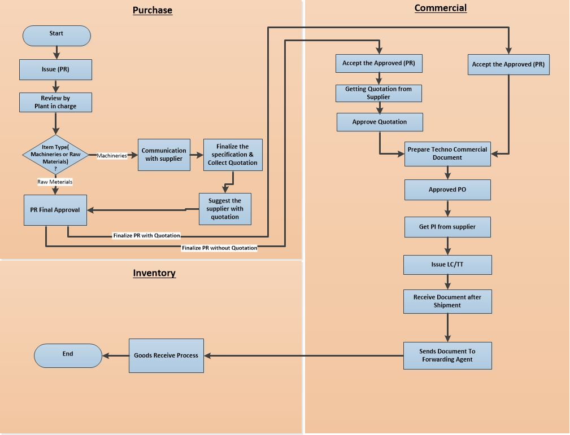

**Fig:** Foreign Import Process

### 4.0.1 Overall Foreign Import Description

There are some pre and post activities before commercial completes its core process. At First storekeeper raise Purchase Requisition (PR) when any department requires any raw material/machinery items. After the review, it may need technical verification. If it needs technical verification, authorized person will communicate with supplier. In the meantime, specification gets finalized and quotation is collected from supplier. At this moment Authorized Person will suggest supplier to Management and Management Personal will approve PR. The PR which don’t need technical verification will have regular PR approval process. Commercial department gives quotation to those PR which has no quotation yet (if needed). The quotation needs to be approved. After the approval of Purchase Requisition (PR) which have quotation for both raw material and machinery items, commercial starts its core activities e.g. Preparing Techno-Commercial document, approved PO, getting Proforma Invoice (PI) from supplier and then Issue LC/TT depends on the purchase order (PO). When the goods are received at Port, relevant documents are sent to forwarding agent (in Case of LC). After that shipments are sent to factory for Quality Control (QC). If the quality of product is ok, the stock of inventory is updated. This is how commercial department completes its end to end process.

The Following are the Sub-Processes of commercial module:

1. Techno Commercial Process
2. Quotation Approval Process
3. Purchase Order (PO) Approval Process
4. LC Process
5. TT Process

## 4.1 Techno-Commercial Process

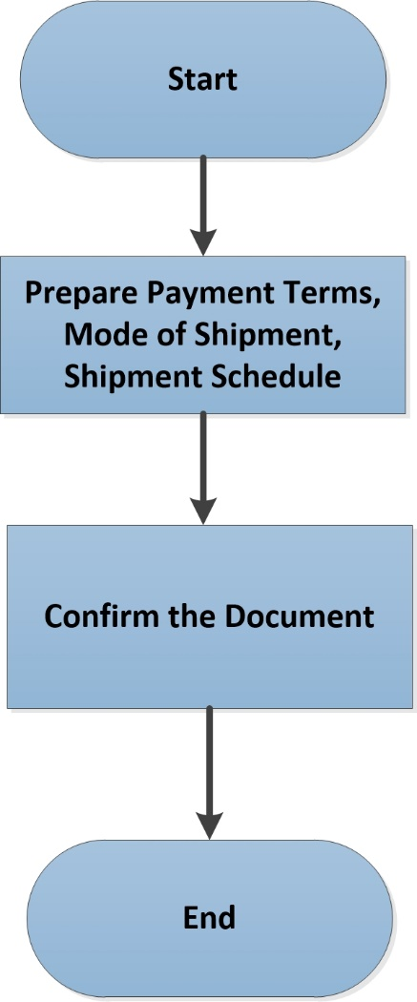

**Fig:** Techno-Commercial Process

### 4.1.1 Process Flow Description

* 1. After approval of purchase requisition commercial department start preparing for techno-commercial document which is both for raw material and machinery items.
  2. After taking all the approval, commercial department sends the quotation to selected supplier/vendor all over the world.
     1. Buyer may be selected depends on good quality, quantity or price etc.
  3. Commercial department prepares a techno-commercial documents which includes mode of shipment, payment terms, shipment schedule etc.
  4. After that all the document will be confirmed by authorized personnel.

## 4.2 Quotation Approval Process

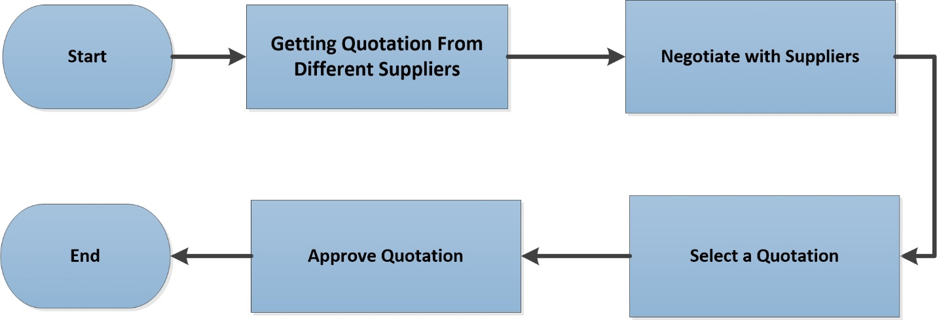

**Fig:** Quotation Approval Process

### Process Flow Description

1. Authorized user/department receives Quotation which was sent by supplier with details specification of materials/products and make negotiation with suppliers.
2. Authorized user/department request to Authorized Manager for the selection of quotation depending on received purchased requisition.
3. Authorized Manager receives the Request and approve the quotation. If they reject it, process will end there.
4. After getting Selection confirmation from Procurement Manager, Procurement Executive creates Purchase Order (PO).

## 4.3 Purchase Order (PO) Approval Process

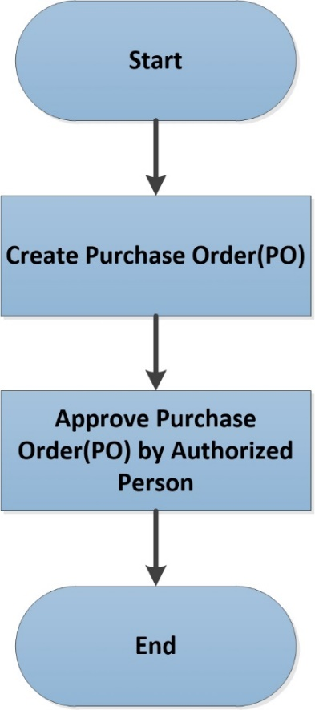

**Fig:** Purchase Order (PO) Approval Process

### 4.3.1 Process Flow Description

1. Authorized user/department will create Purchase Order (PO) against the Purchase Requisition (PR). One PR can have multiple PO.
2. Once vendor is selected Authorized user/department starts processing on purchase order (PO).
3. Purchase Order (PO) will have its unique order number, specific terms and conditions, supplier and consignee information etc.
4. This purchase order now needs to go through one approval layer based upon value or quantity or product.
5. The Purchase Order PO and Purchase Requisition (PR) approver will have to be the same person. Approver can update quantity, unit rate etc. Approver can reject the PO also.
6. Once all the approval processes are complete then the PO is given to the vendor.

## 4.4 Letter of Credit (LC) Process

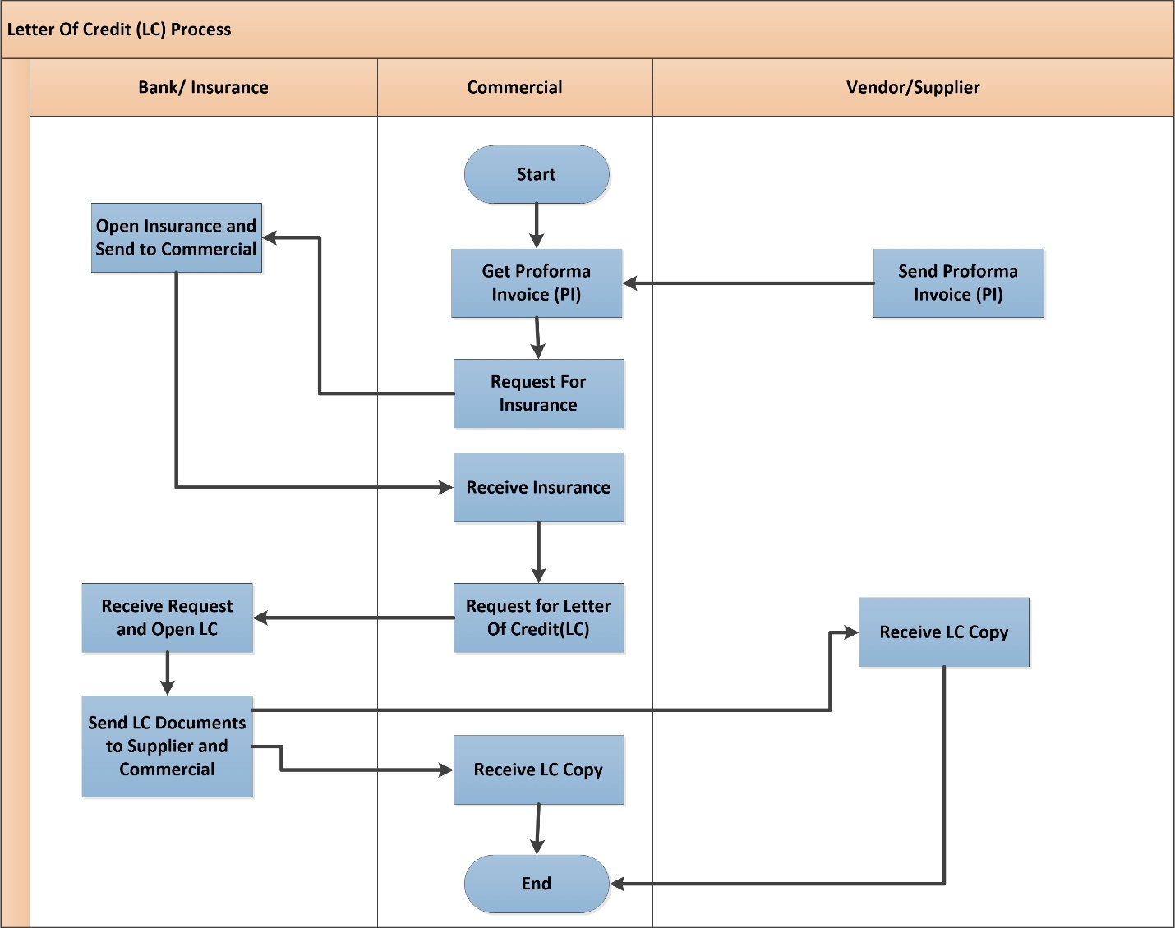

**Fig:** Letter of Credit (LC) Process

### Process Flow Description

1. After getting PI from supplier commercial department request for insurance.
2. Buyer applies to his bank for insurance to process LC and after opening insurance bank sends the insurance copy to commercial.
3. After that commercial requests for LC to the bank and buyer’s bank open a LC.
4. Buyer's bank approves the credit risk of the buyer, issues and forwards the credit to its correspondent bank (advising or confirming). The correspondent bank is usually located in the same geographical location as the seller (beneficiary). Advising bank will authenticate the credit and forward the original credit to the seller (beneficiary).
5. Seller (beneficiary) ships the goods, then verifies and develops the documentary requirements to support the letter of credit.
6. Seller presents the required documents to the advising or confirming bank to be processed for payment. Advising bank examines the documents for compliance with the terms and conditions of the LC.
7. If the documents are correct, the advising or confirming bank will claim the funds by debiting the account of the issuing bank (buyer’s bank), waiting until the issuing bank remits after receiving the documents.
8. Advising or confirming bank will forward the documents to the issuing bank. Issuing bank will examine the documents for compliance. If they are in order, the issuing bank will debit the buyer's account.
9. Issuing bank then forwards the documents to the buyer.
10. One Proforma Invoice (PI) will issue one Letter of Credit (LC) only.

## 4.5 Telegraphic Transfer (TT) Process

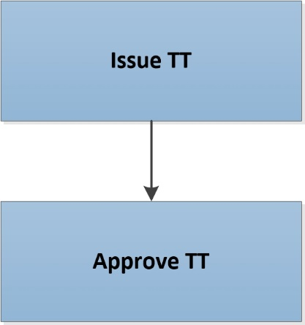

**Fig:** TT Process

### 4.5.1 Process Flow Description

1. Samuda sometimes use TT for emergency purpose or specific amount which will be mentioned in PO.
2. TT stands for telegraphic transfer, a form of bank transfer. TT payments are cheap and fast way of transferring money overseas through most banks.
3. Bank transfers (also known as telegraphic transfers or TT) is one of the simplest forms of international transfers. In traditional international trade, it’s risky for buyers to pay using bank transfers because their money goes into the suppliers’ bank account directly - before they are able to receive their order.
4. TT, Telegraphic Transfer of money was effected by a cable message service from one bank to another to transfer money. TT payment was very popular prior to existence of electronic payment networks. Telegraphic transfer is operated by cable message and TT is treated one of the other electronic fund transfers.
5. While payment done on TT, buyer should remember certain things in their mind such as (get the beneficiary name, address and other account details right, the right company name, pay all the bank transaction fees including beneficiary bank fees, save a transaction record and send it to supplier etc.)

## 4.6. Other Key Points of Foreign Import

1. After approval of purchase requisition commercial department start preparing for techno-commercial document which is both for raw material and machinery items.
2. After taking all the approval, commercial department sends the quotation to selected supplier/vendor all over the world.
   * 1. Buyer may be selected depends on good quality, quantity or price etc.
3. Commercial department prepares a techno-commercial documents which includes mode of shipment, payment terms, shipment schedule etc.
4. After that commercial module will issue purchase order (PO) and it will have its required approval process. One Purchase Requisition (PR) can have multiple PO (Purchase Order).
5. Then commercial department receives one Proforma Invoices (PI) from selected supplier. One purchase Order (PO) may have multiple PI.
6. After getting the PI, commercial department issue LC/TT. One PI will issue one LC only.
7. There will have checklist for issuing LC and there will be a stage overview indicating the process is in which stage. Every stage will contain its relevant documents.
8. All the communication must be recorded and will be used as supporting documents.

# **Overview of Foreign Export and its Processes**

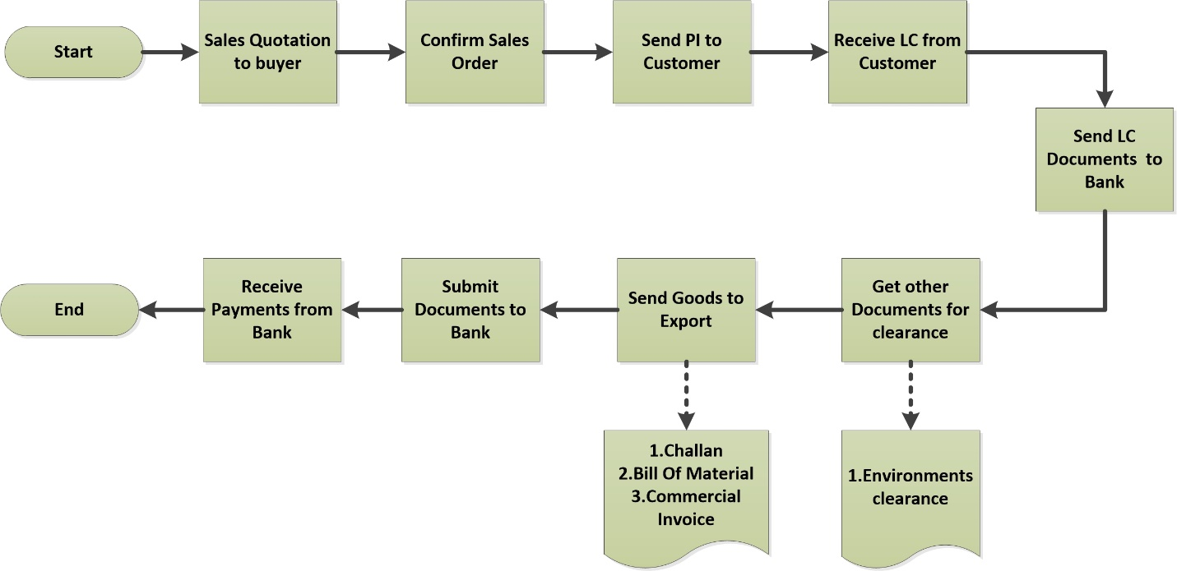

**Fig:** Foreign Export Process

### Overall Foreign Export Description

An **export** is a function of **international** trade whereby goods produced in one country are shipped to another country for future sale or trade. The sale of such goods adds to the producing nation's gross output.

For the foreign export samuda prepare sales quotation and send it to buyer. Sales order is confirmed at the same time where payment terms are defines also. Seller sends Proforma Invoice (PI) to buyer. After that seller receives LC request from customer and sends LC document to bank. Seller will receive other documents for clearance. After the clearance of other documents, goods will be exported (including challan, bill of material, commercial invoice etc.) to the mentioned location. Relevant document will be submitted to the bank and seller receives payment from bank.

# **6. Appendix**

1. File Check List:

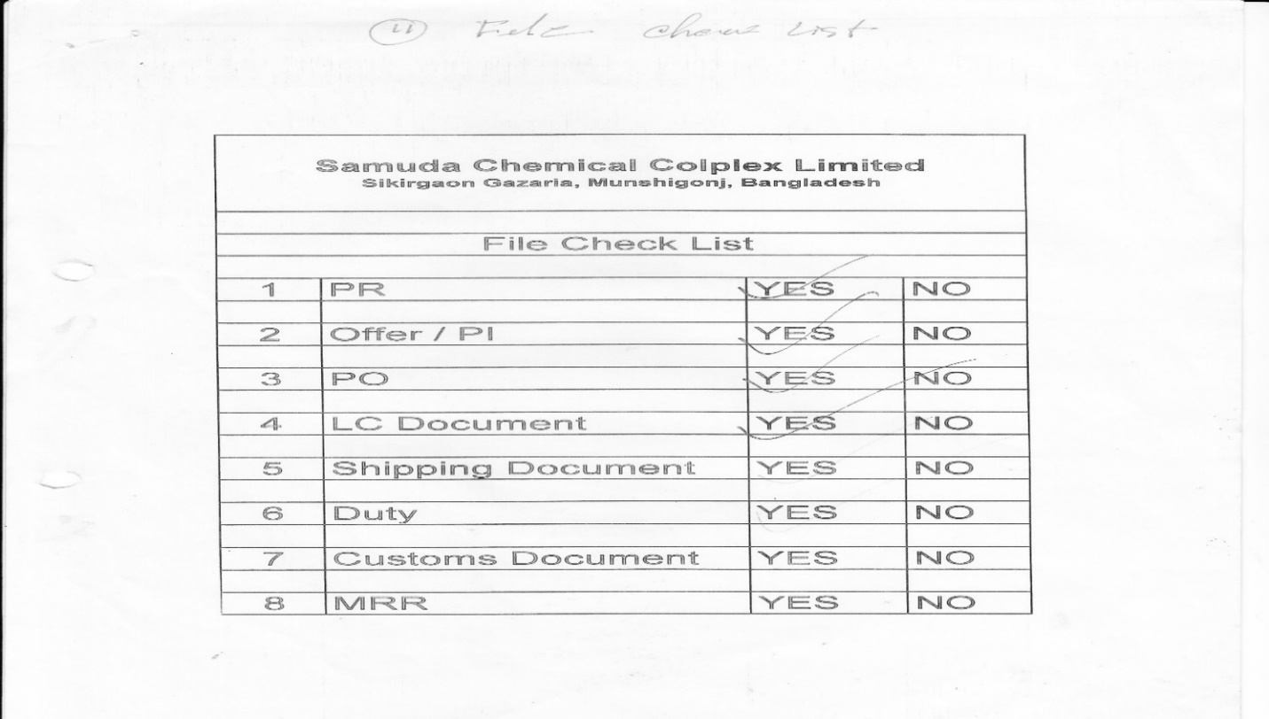

1. Purchase Requisition (PR):

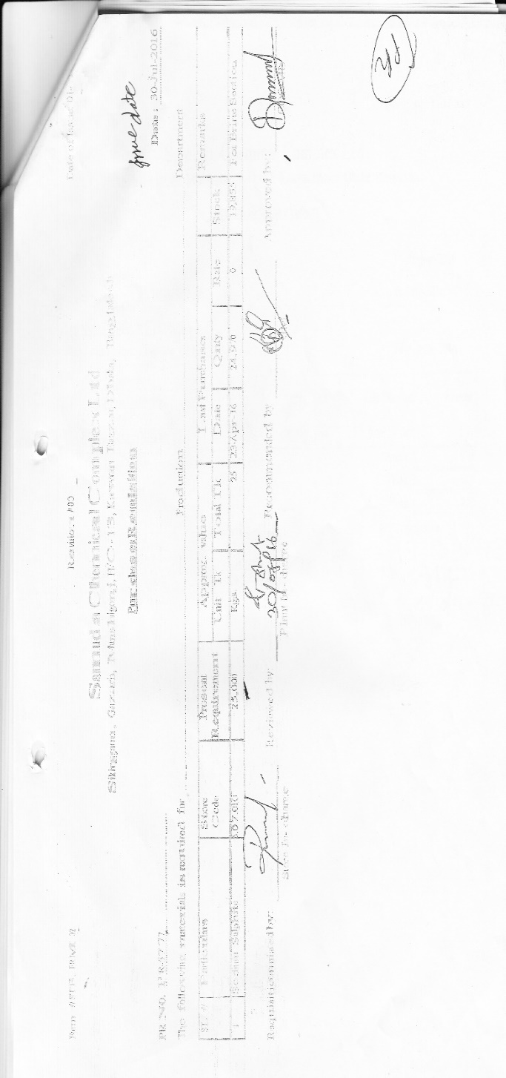

1. Quotation:

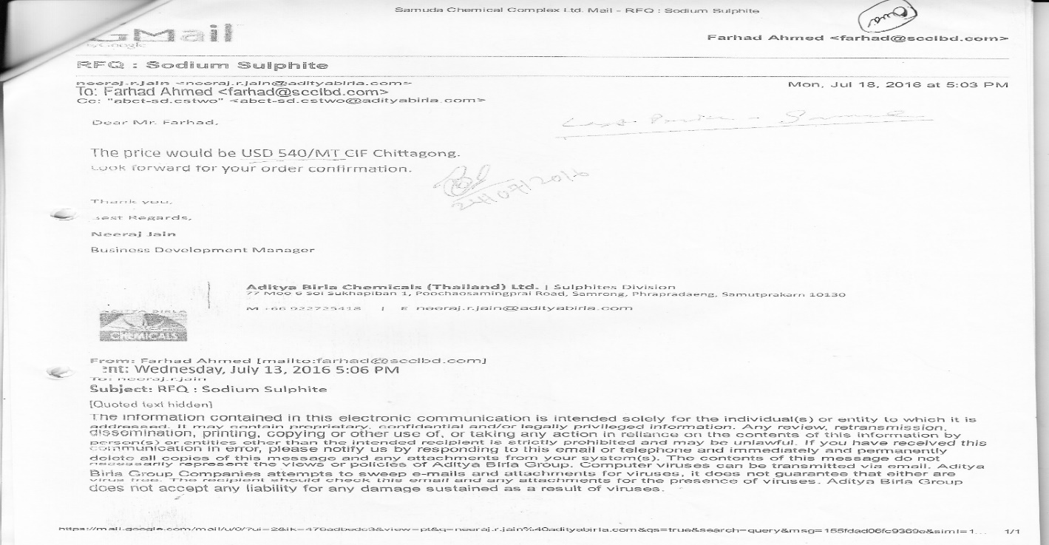

1. Quotation:

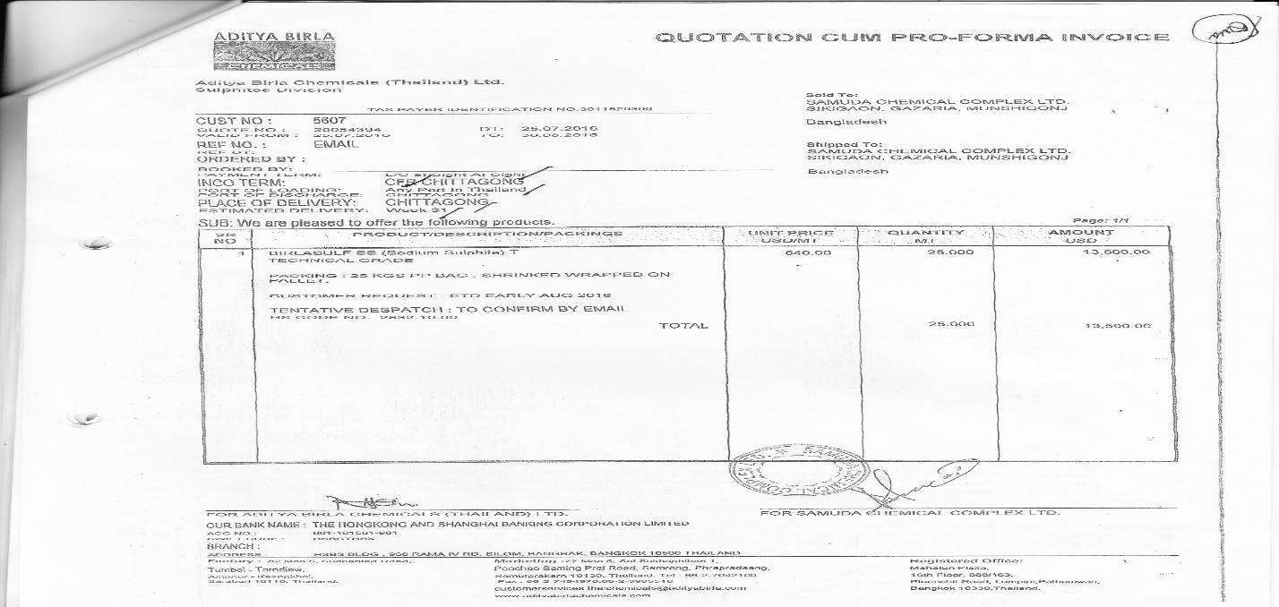

1. Purchase Order (PO):

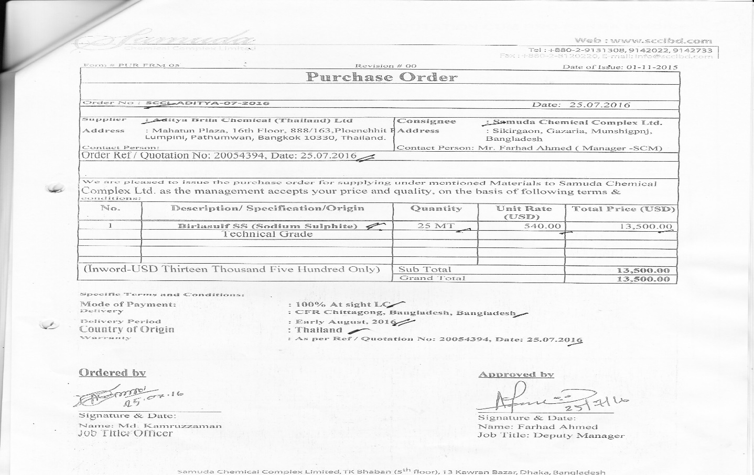

1. Proforma Invoice (PI):

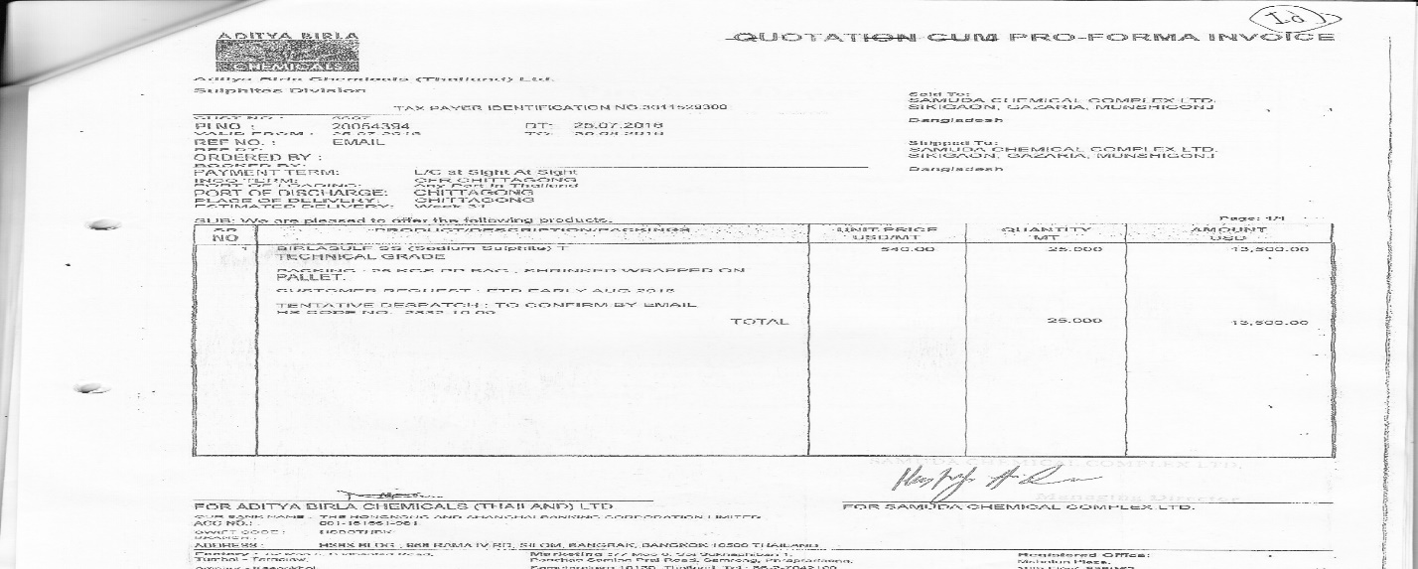

1. Insurance:

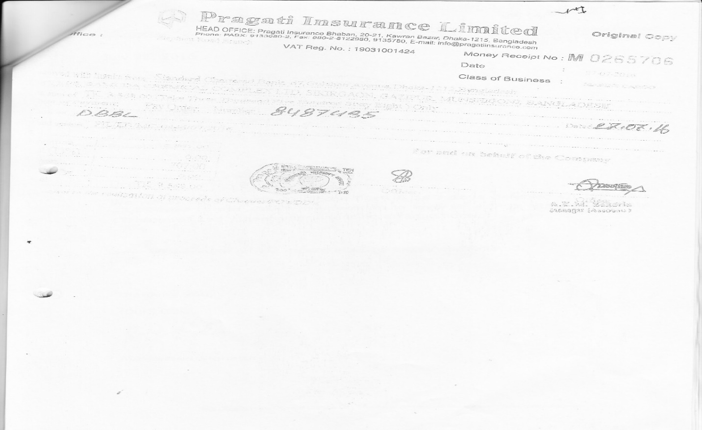

1. LCF:

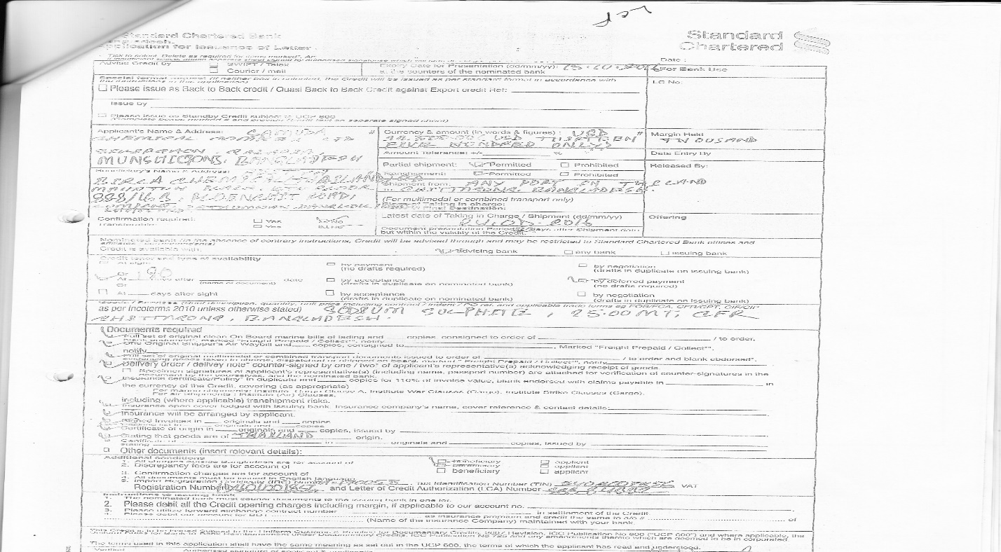

1. Bank Forwarding:

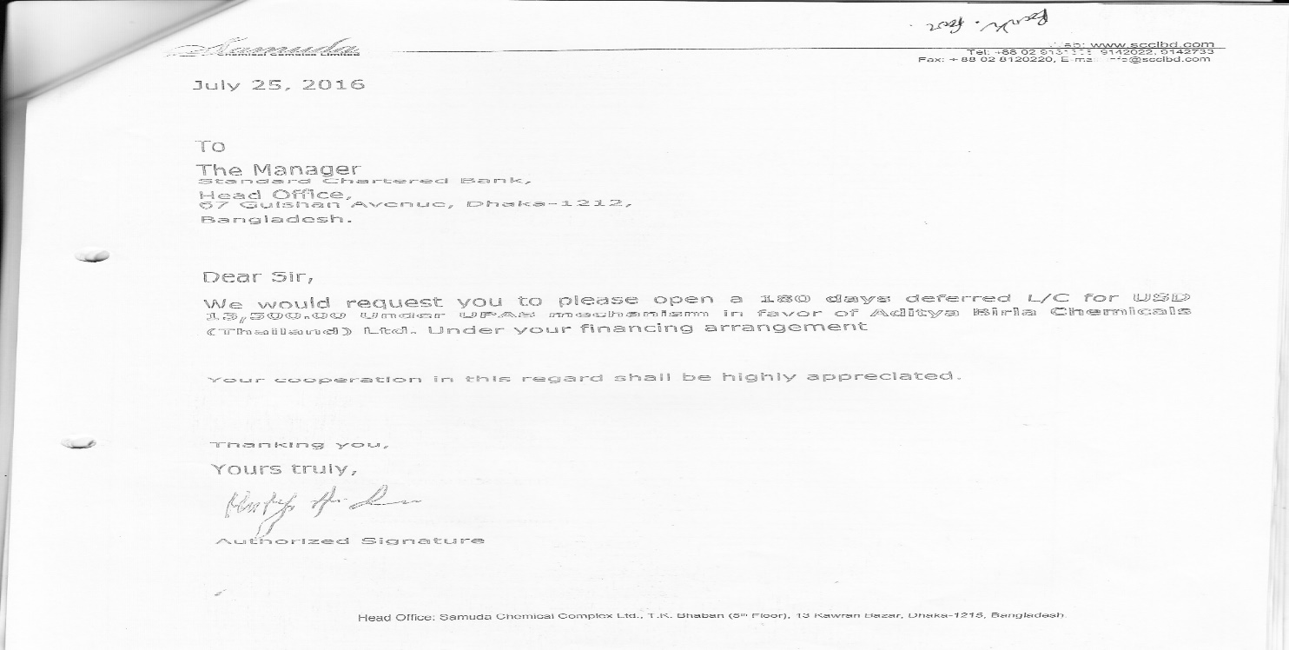

1. LC Copy:

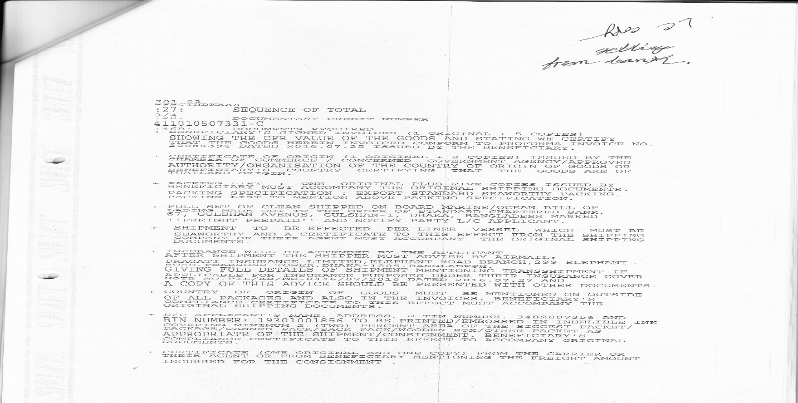

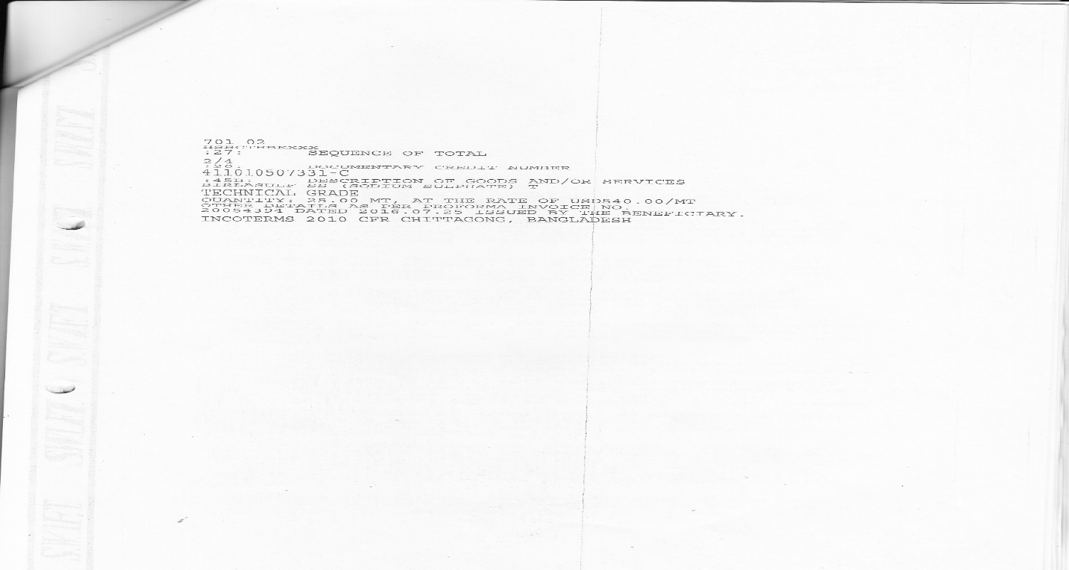

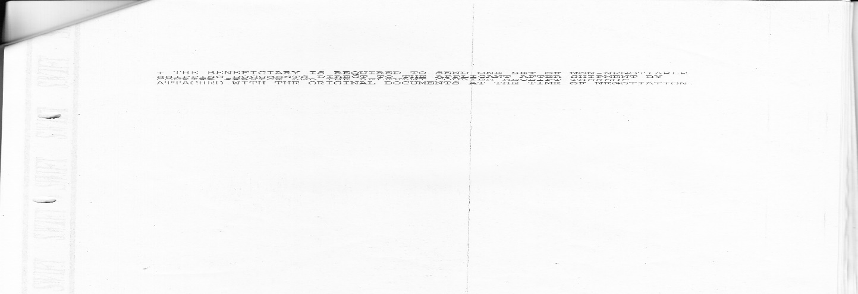

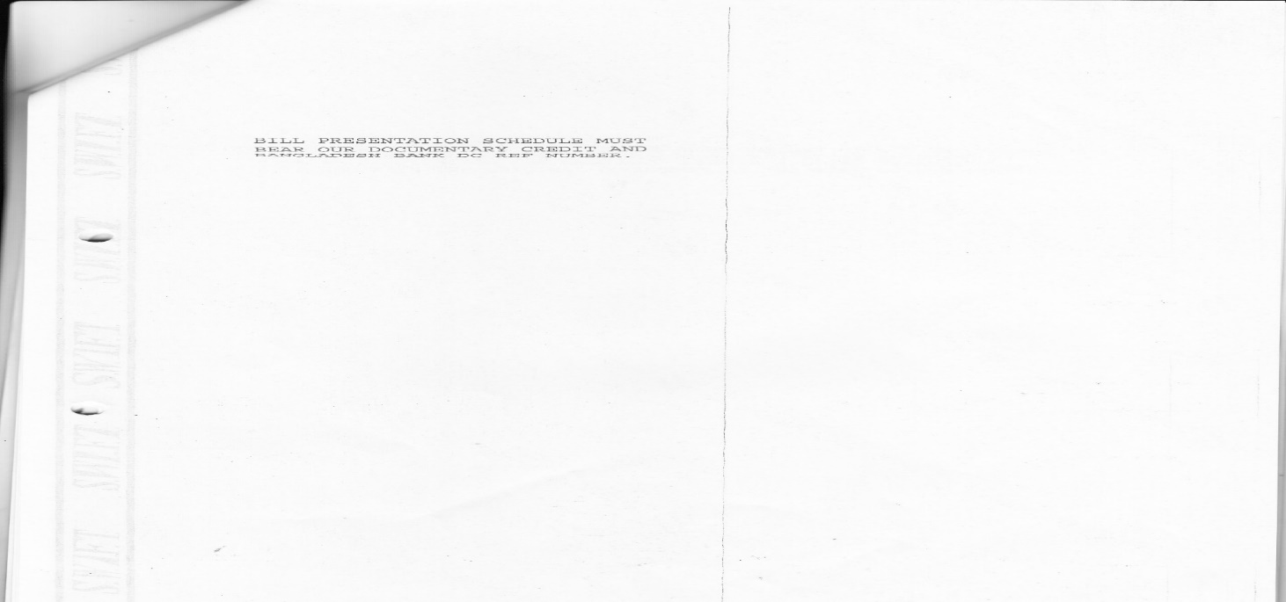

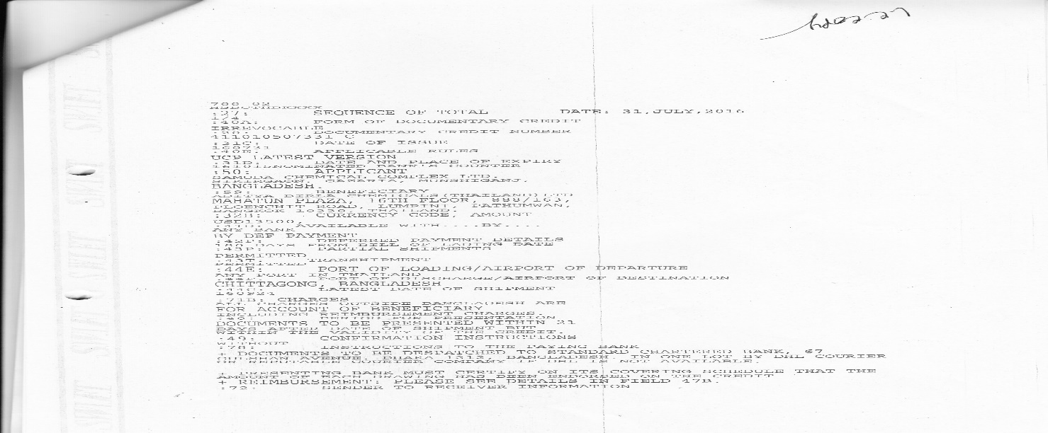

1. Shipping Document:

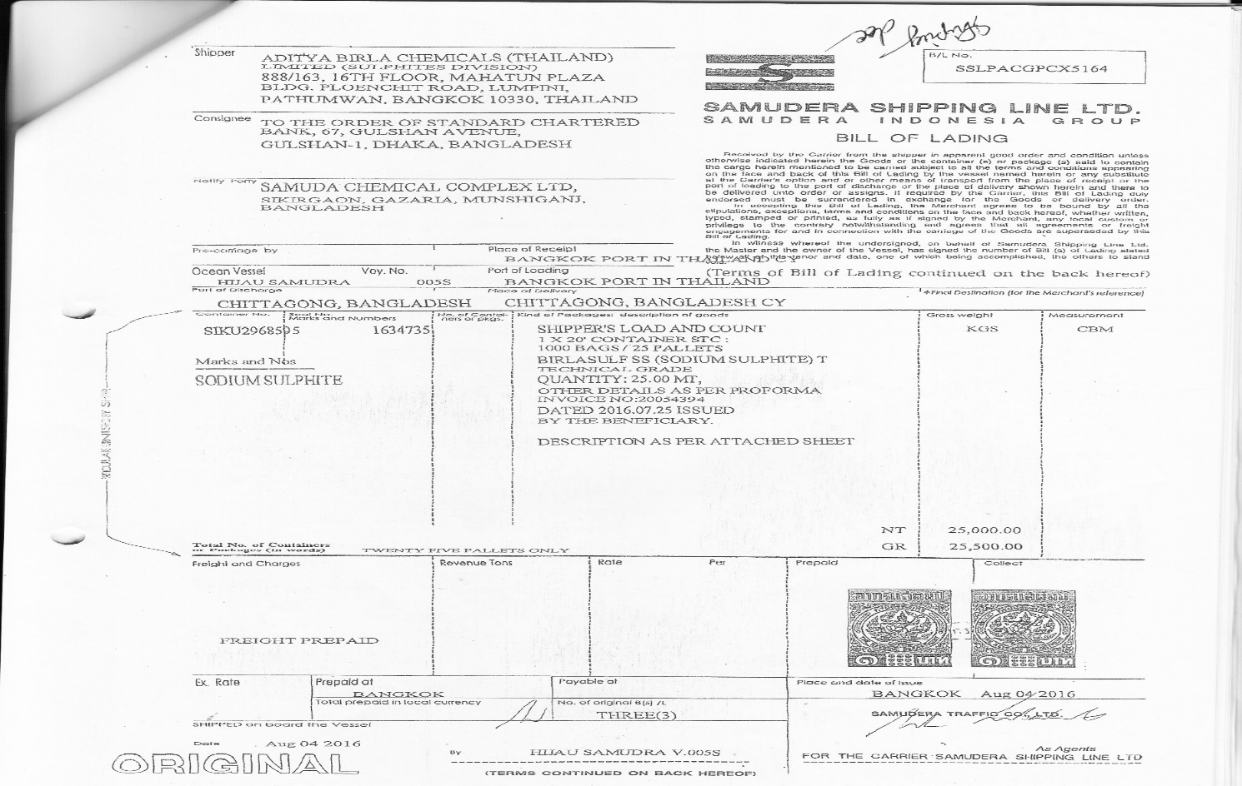

1. Packing List:

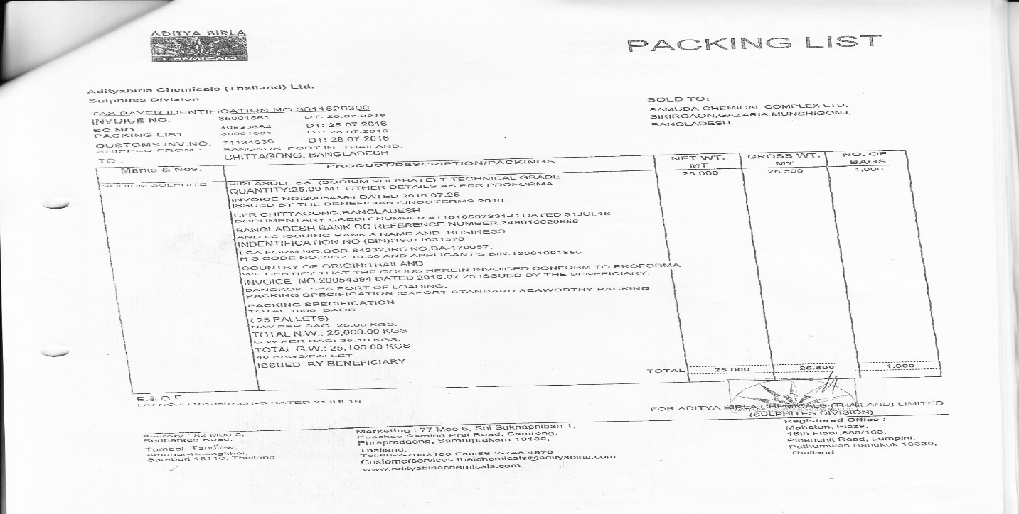

1. Shipping Document(Invoice) :

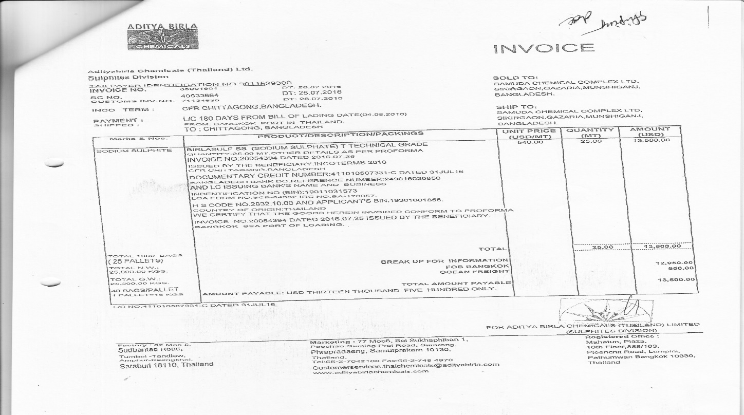

1. Bill Of Entry:

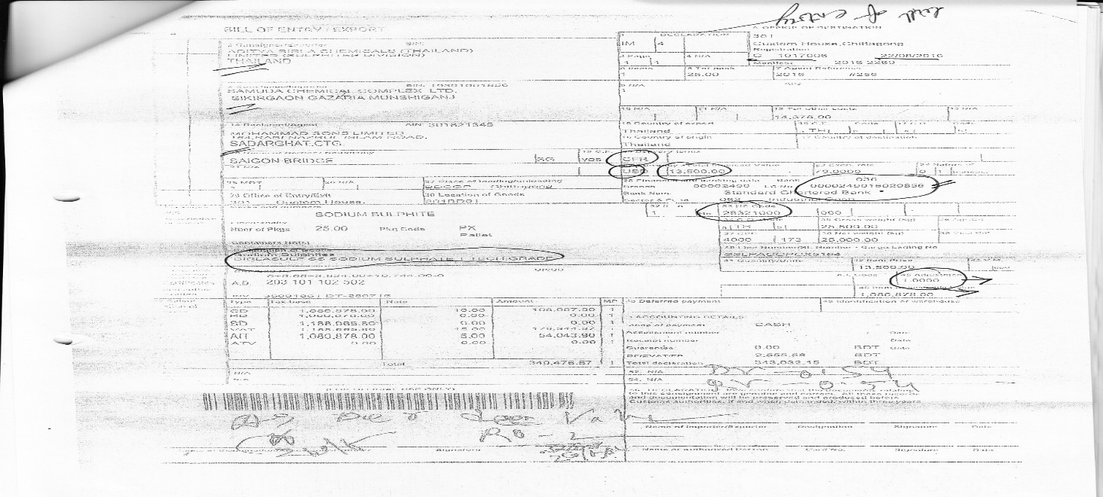

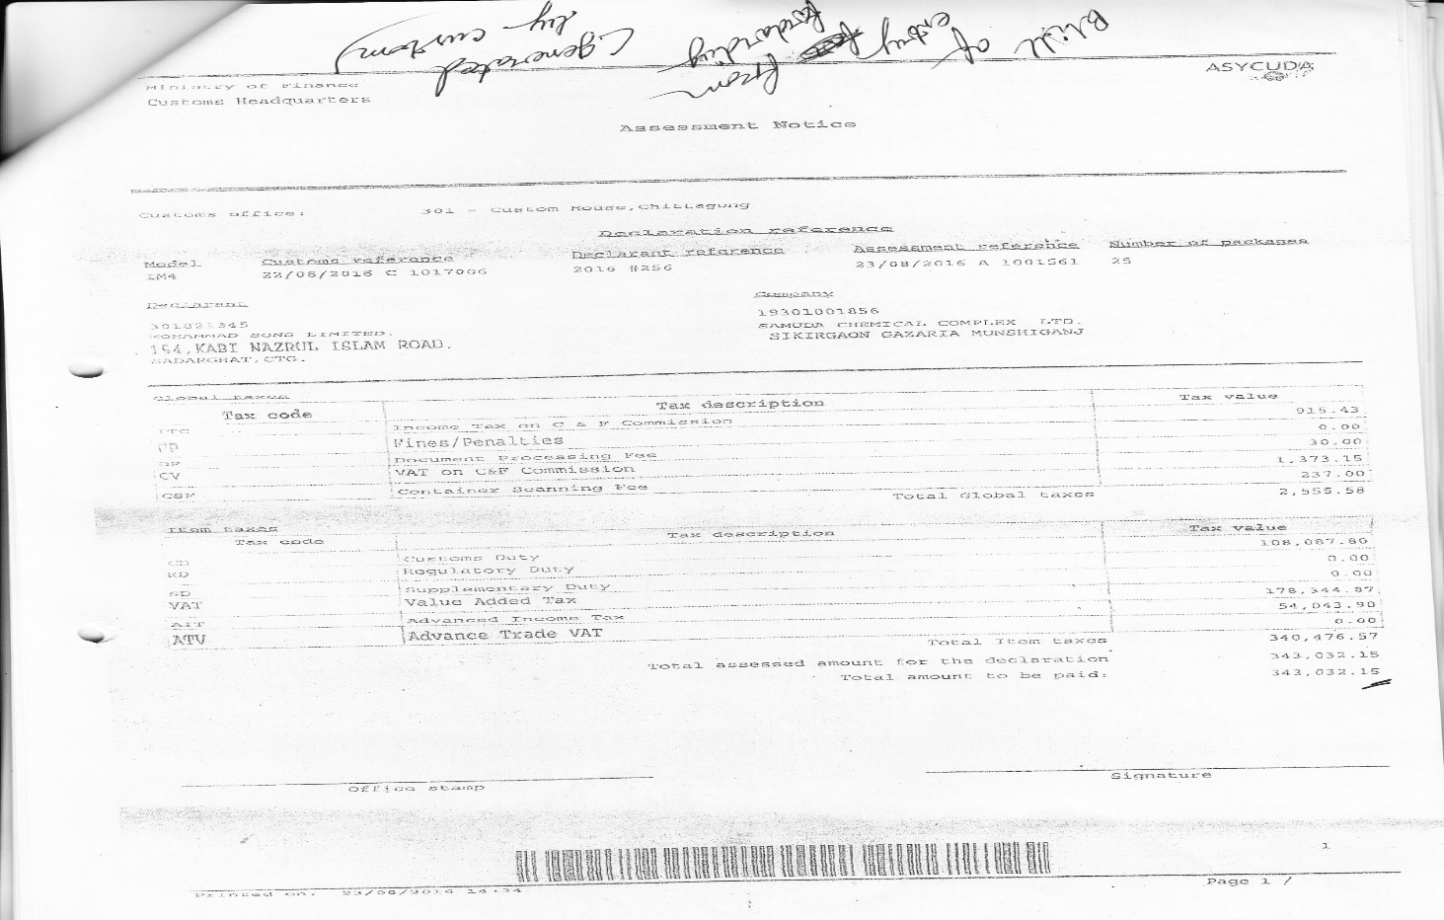

1. CNF Requisition:

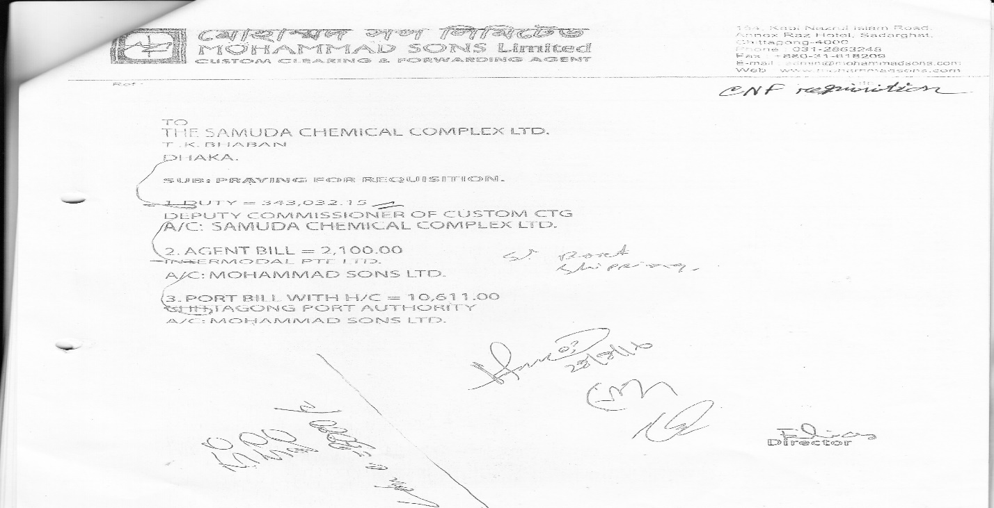

1. QC Report:

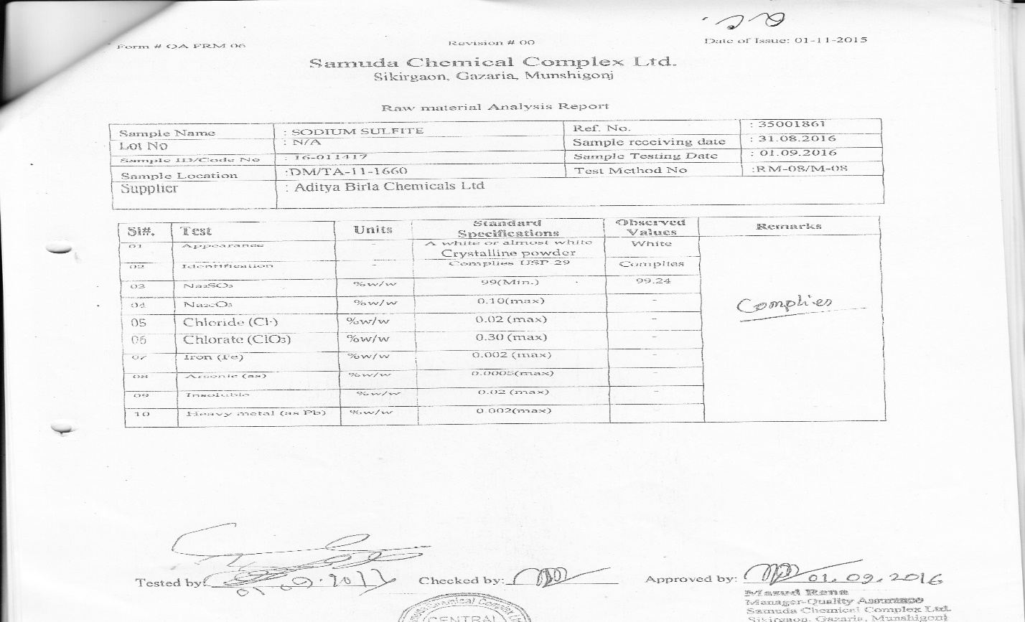

1. Material Receiving Report:

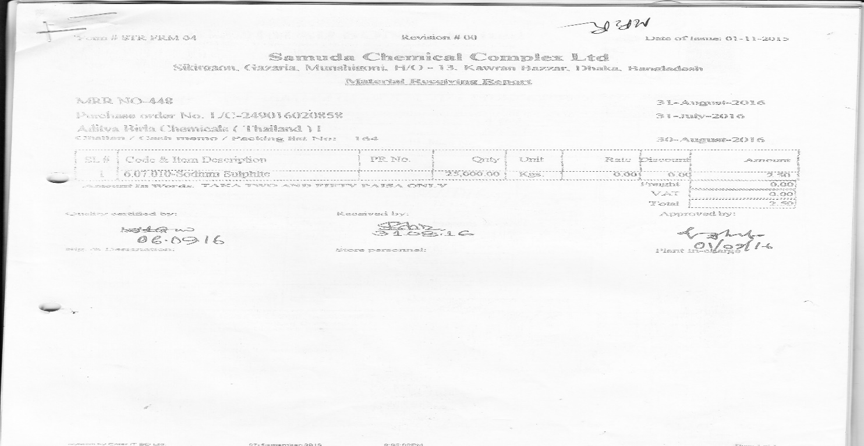

# **7. To be Determined**

1. ISO 9001 related reports are not implemented within this phase. We will cover in next phase.

Signed on behalf of Signed on behalf of

Samuda Chemicals Ltd. Genweb2 Limited

Name: Name:

Designation: Designation:

Date: Date:

**______________________________ ______________________________**

Signature Signature